Supplemental Digital Content 1. Figure S1. Arterial and portal flow throughout first 120 minutes of dual hypothermic oxygenated machine perfusion.

A.
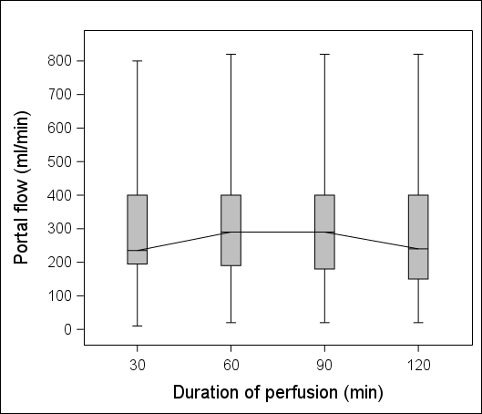

B.
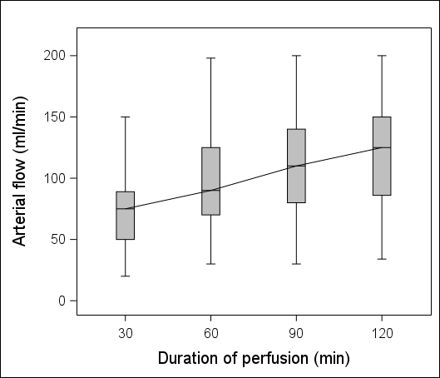

Supplemental Digital Content 2. Table S1. Postoperative complications after deceased donor liver transplantation preceded by dual hypothermic oxygenated machine perfusion (dHOPE) or static cold storage (SCS) according to Clavien-Dindo classification.
Complication / Management | dHOPE | SCS
Grade V (death) | 1 | 6
Grade IVB
multi-organ failure - cardiac and renal insufficiency (vasopressors and dialysis) | 1 | 2
multi-organ failure - cardiac, respiratory, and renal insufficiency (vasopressors, respiratory support, and dialysis) | 1 | 5
multi-organ failure - cardiac, respiratory, renal, and liver (HAT) insufficiency (vasopressors, respiratory support, and dialysis) | 0 | 1
multi-organ failure - cardiac, respiratory, renal, and liver (PNF) insufficiency (vasopressors, respiratory support, and dialysis) | 0 | 2
multi-organ failure - cardiac and respiratory insufficiency (vasopressors and respiratory support) | 0 | 2
multi-organ failure secondary to sepsis (biliary tract infection due to stricture) | 0 | 1
Grade IVA
renal insufficiency (dialysis) | 2 | 3
circulatory insufficiency (vasopressors) | 0 | 2
Grade IIIB
intraabdominal fluid collection – relaparotomy and drainage | 0 | 1
intraabdominal hematoma - relaparotomy and drainage | 0 | 2
wound bleeding – operative revision and haemostasis | 0 | 2
intraabdominal bleeding – relaparotomy and haemostasis | 5 | 3
primary packing following LT – relaparotomy and depacking | 0 | 1
intraabdominal bleeding – relaparotomy and packing | 0 | 2
primary nonfunction - reLT | 0 | 1
hepatic artery thrombosis – reLT | 0 | 1
biliary fistula - relaparotomy and drainage | 0 | 1
revision after secondary packing – relaparotomy, depacking, and drainage | 0 | 2
biliary fistula - relaparotomy and biliary reanastomosis | 0 | 2
biliary fistula - relaparotomy and biliary T-drainage | 1 | 0
biliary fistula - ERCP | 0 | 5
biliary stricture - ERCP | 0 | 4
biliary stricture – ERCP (readmitted to hospital) | 0 | 1
intraabdominal bleeding, necrotizing pancreatitis – relaparotomy and drainage | 0 | 1
melaena - gastroscopy | 0 | 2
pneumonitis, respiratory insufficiency - bronchoscopy | 0 | 1
portal vein thrombosis - relaparotomy and portal vein anastomosis redo | 0 | 1
Grade IIIA | 2 | 13
paracentesis | 0 | 3
pleurocentesis | 2 | 6
radiologic embolization of arterial bleeding | 0 | 2
percutaneous biloma drainage | 0 | 1
embolisation of thyro-cervical artery aneurysm (due to failed central vein cannulation) | 0 | 1
Grade II | 16 | 54
atrial fibrillation (amiodarone) | 0 | 1
urinary tract infection - altered antibiotic regimen | 0 | 1
blood transfusion | 15 | 43
total parenteral nutrition | 1 | 5
diarrhoea - C. difficile (oral vancomycin) | 0 | 2
intraabdominal infection - altered antibiotic regimen | 0 | 2
Grade I | 4 | 16
bedside evacuation of wound hematoma | 0 | 3
diuretics | 1 | 2
complication of tracheal intubation - aphonia | 1 | 0
prolonged abdominal drainage | 1 | 7
peroneal nerve paralysis | 0 | 1
pneumothorax | 0 | 1
small intraabdominal hematoma (conservative) | 1 | 0
bedside management of wound bleeding | 0 | 1
diarrhoea - negative C. difficile | 0 | 1
Includes multiple complications in a single patient.
dHOPE – dual hypothermic oxygenated machine perfusion; SCS – static cold storage; LT – liver transplantation; PNF – primary nonfunction; HAT – hepatic artery thrombosis; ERCP – endoscopic retrograde cholangiopancreatography

